Ionad Eachdraidh an Rois Mhuilich
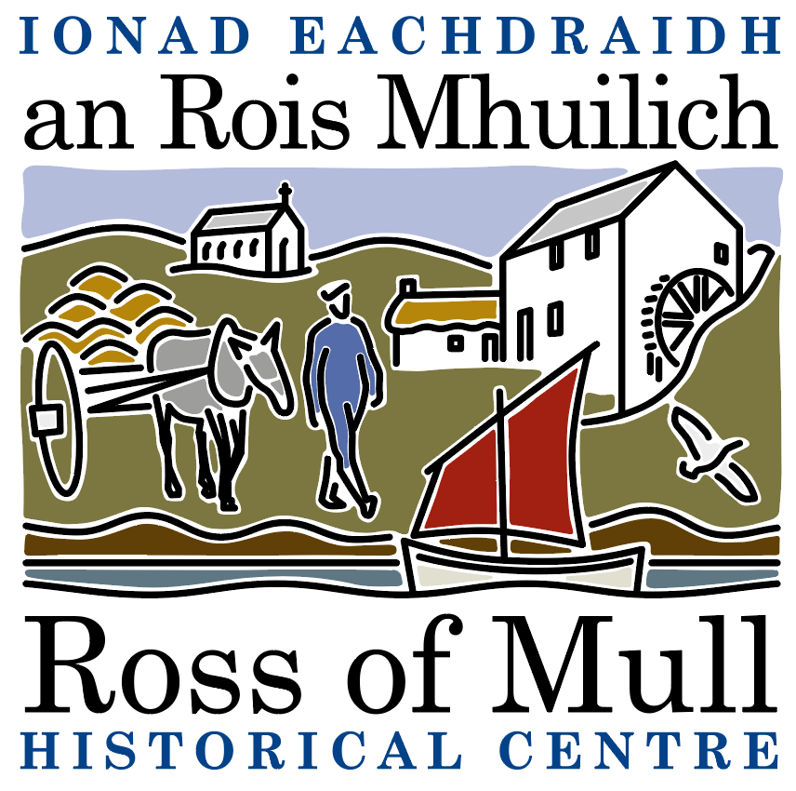

Millbrae Cottage, Bunessan, Eilean Mhuile, ARGYLL, PA67 6DG 01681 700 659 E: enquiries@romhc.org.uk

SCIO No: SC 030873
Ross of Mull Historical Centre

Agenda for 2024 Annual General Meeting

To be held on Saturday 30th November, 2024 at 2.00 pm
at the Ross of Mull Historical Centre, Millbrae Cottage, Bunessan

1. Present

2. Apologies

3. Minutes from the 2023 AGM

4. Approval of Financial Statements

5. Trustees Report

6. Mill Project

7. Election of Directors
Current Trustees are Anne Baxter, Sue Clare, Alex Fletcher, Judy Gibson, Roger Harvey, Tessa Howell, Jan Sutch Pickard. At the AGM under SCIO, all are required to stand down, but all can be reappointed at this meeting.

8. AOCB

To be followed by a talk by Emily Wilkins, Ranger - South Mull, Iona, Burg, Treshnish Isles and Staffa NNR, ‘NTS: a year of change and learning’

